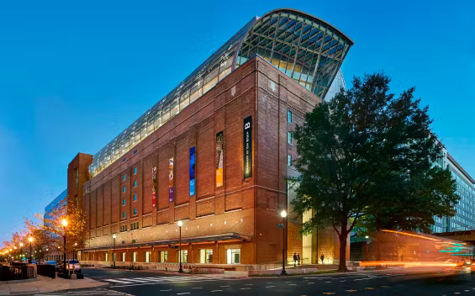
The Bible Museum in Washington, DC

Where faith comes alive

Day Trip

April 6, 2026

General Admission plus bus seat
Non-Member Adult (18–64) |  | $155
Non-Member Senior (65+) Walk-Up |  | $130
Military, First Responders, and Students Walk-Up with ID |  | $130
Non-Member Youth (5–17) |  | $125
A Nonrefundable deposit of $25.00 required to hold your seat due !-31-2026
Final Payment due: Mar. 31, 2026, installment payment are welcomed.
All seats are final. Contact

Dr. E@GRUP Opportunity Travel Services, Inc.@
757-556-6338 or 404-402-1883
Website: grupopportunitytravel.com
2506 Jefferson Ave. Suite 101, Newport New, VA 23607

Pick up location to be announced.

